Activity |  |  | Sea Kayak Trip |  |  |  | Centre | North Shore |  | Location |  |  | Hauraki Gulf |  |  | Difficulty¹ |  |  |  | Intermediate
Activity Description |  |  | Long Bay to Shakespear return (Te Haruhi Bay) |  |  |  |  |  |  |  | Leader qualification req.² |  | Trip Leader
Get in Location |  |  | Long Bay |  |  |  |  |  |  |  | Chart/ Map no.⁴ |  | 5321 |  |  | Distance |  |  |  | 25 km
Get out Location |  |  | ditto |  |  |  |  |  |  |  | Coastguard Channel |  | 82 & 16 |  |  | Nowcasting |  |  |  | 21
Emergency get out ⁵ |  |  | All bays and coastline at mid/low tide |  |  |  |  |  |  |  | Emergency / Coastguard Station |  | Auckland |  |  | Phone |  |  |  | *500  09 303 4303
 |  |  |  |  |  |  |  |  |  |  | Drinking Water⁶ |  |  | At all bays | Toilets⁷ |  |  |  |  |  |  | ^{at all bays}
Emergency Response |  |  | Refer Emergency Response Booklet |  |  |  |  |  |  |  |  |  |  |  | Parking⁸ |  |  |  |  |  |  | At Long Bay
Specific Equipment Required⁹ |  |  |  |  |  |  |  |  |  |  | Working Communications equipment in this area¹⁰ |  |  | Cell phone  Sat phone |  |  |  |  |  |  | PLB  VHF
Other resources  and notes¹¹ |  |  |  |  |  |  |  |  |  |  | Weather Parameters¹² |  |  | 25 kn in exposed areas  Swell 1.5m or less
Previous incidents¹³
Safety Management¹⁴
Hazard |  | Significant?  - E/I/M |  |  | Management Strategy¹⁵ |  |  |  |  |  | Hazard | Significant?  - E/I/M | Management Strategy¹⁵
Cold Water |  | Yes - M |  |  | Carry spare dry clothes and shelter |  |  |  |  |  | Deep Water | Yes - E | Correctly fit PFDs
Medical Conditions |  | Yes - M |  |  | - Leader has first aid qualification  - Ask customers about medical conditions |  |  |  |  |  | Bad Weather | Yes - M | Understand weather forecasts.  Have back up plans or pull out if necessary
Capsizing |  | Yes - M |  |  | - Correctly fit PFDs  - Skills at performing rescues. |  |  |  |  |  | Heat / Sun | Yes - M | - Protective Clothing (worn), Sunglasses, Hat  - Sun Screen  - Plenty of drinks
Panic |  | Yes - M |  |  | Ensure conditions match level  of skills |  |  |  |  |  | Obstacles | Yes - M | Awareness of reefs, navigational hazards, nets
Gulf Harbour Marina |  | Yes |  |  | - Take care crossing the Marina entrance – watch out for traffic – see other vessels. |  |  |  |  |  | Other Vessels | Yes - M | - Understand the “rules of the sea”  - “Be seen” – Have two of the following; flag, brightly coloured kayak, brightly coloured Pfd or hat. At night: an all- round white light & a powerful torch.
Other Hazards |  |  |  |  |  |  |  |  |  |  | Other Hazards
Written up by: | Joya Todd |  |  | Approved By: |  | Rob Howarth |  |  | Signed: | 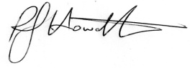 |  | Date: | 16/4/2014 |  |  |  | Review in: |  | 12 months from date of approval
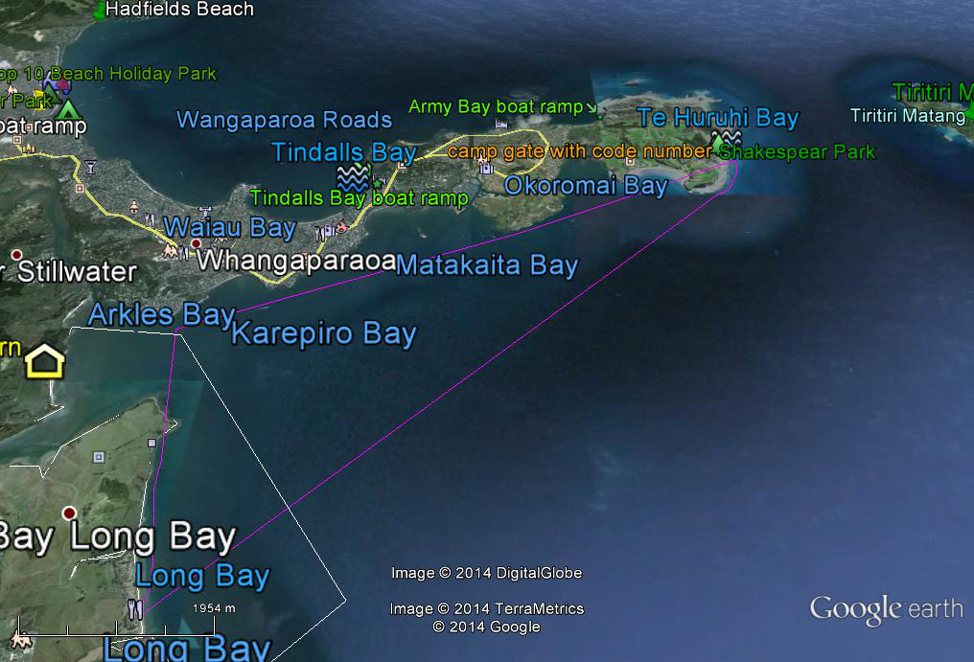
Additional Information Sheet (Optional)
Introduction (A general introduction)
Description (A description of the tour – as if you were selling the idea to someone)
Local Attractions |  | Transport/ Local Operators
 | Contact details |  | Contact details
Local Eateries
 | Contact details
Accommodation/ Campsite Locations |  |  | Facilities
Name |  |  | Cabins |  | Fuel
Phone |  |  | Showers |  | Power
E-mail |  |  | Toilets |  | Water Access
Website |  |  | Laundry |  | Pool
Physical Address |  |  | Water |  | Fires Allowed
Other |  |  | Supplies
Other information

Activity Equipment Check list
Equipment List
- Helmet (rivers & surf) Group Gear
❑ Beanie / hat  Split paddles
❑ Thermals  Repair kit
❑ Paddle Jacket  Fire lighting
❑ PFD  Cooker/thermos
❑ Spray deck  Spare thermals
❑ Booties  Tow system
❑ Water & food  1st Aid Kit
❑ Kayak & paddle  Flares
Group - Oceans & Lakes  Compass
❑ Pumps & Paddle Floats  Charts / Maps
Group - River  GPS (optional)
❑ Throw ropes  Knife (cut rope)
❑ Pin kit & saw  Emergency Shelter

In case of emergency: Dial 111, Mayday :VHF Channel 16

Kayaking Check list

❑ Trip plan
❑ Latest weather forecast
❑ Conditions match skills?
❑ Hyperthermia (hot) &
Hypothermia (cold)
❑ On & off water safety
❑ Environmental concerns
❑ Emergency Procedures include emergency get out.
❑ Working communication devices
e.g. VHF radio, mobile phones, PLB
❑ Specific safety issues for this trip
❑ Participant list
❑ Any medical conditions
❑ All participants keen to proceed?

❑ Trip Plan/ 2-minute form lodged with Ops. Manager

Appropriate wind conditions to run trips:
Novice - no significant surf or swell, wind under 15knots
Intermediate- surf or ocean swells less than 1.5 meter or wind under 25 knots.
Advanced- any condition that is suitable to the trips aims

At conclusion of trip:
Contact check in person
Group Debrief.

Check in Person Ph:
__________________ Mobile
__________________ Work
__________________ Home

Activity Document Cover Sheet

Activity:
Date of Activity:

Activity reports. Is all relevant information present:
– Approved Trip Management Plan (TMP)/ 2 minute form
– Club Trip Participant Sheet
– Weather forecast
– Activity Check List
– Trip report (May be on the 2 minute form)
– Accident / incident reports
Leaders Signature:
Date:

